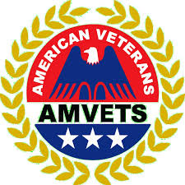
Membership Department
2020
AMVETS Leadership Technology Training
(LTT)
Let there be Light

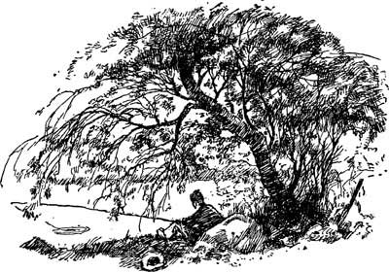
Using this new-found knowledge go forth and teach. For if you give a man a fish he can eat for a day, if you teach a man to fish he …………. gone fishing

Table of Contents
- Cover
- Table of Contents
- Overview
- Login (www.AMVETS.org)
- Edit and Renew Online (annual members)
- Add New Member Dept/Post Join form Step 1
- Payment for Member Dept/Post payment form Step 2
- Member Roster (using the roster as a tool)
- Your E Roster
- Sorting the K column (expiration date)
- K column management and email
- Filter Annuals
- Q columns and emails
- Recap
- Revalidation Online
- Replace Lost Cards online
- Transferring members
- Recruiting Kits
- Vietnam Commemorative Partner
- Member Edit and Renew online (save a tree)
- Member Edit, new card and renew online continued
- Member Renew online
- Leaders Access
- Leaders Access (search for a post member)
- Leader Access (update member)
- National Guard Handout
- Uncle Sam Poster
- FAQs p1
- FAQ p2
- Build a Post 4 steps
- Post Charter Application
- Post Charter checklist
- Flag Day
- Flag Day

Overview: The AMVETS Database
- Need help email (membersupport@amvets.org)
- 2005-2017 ABILA 12 years in the making evolves every day with technology
- AMVETS database is on ABILA servers firewall tape backup systems
- All members have access to their personal database information & can renew online
- Post Leaders have Access to their Post members information
- Department Leaders have access to Department, Posts and Members access

Post Leaders with Access Department Leader with Access
Post Commanders Department Commander
Post 1st Vice Department 1st Vice
Post Adjutant Department Adjutant
Post Renewal Contact Department Renewal Contact
Department Executive Director
The Basic equipment of today won’t be the basics in 5 Years. We have to keep up!
- Post computer with at least windows 7 operating system NT-95-98-2000-XP --Vista-- Windows 7-win8.10 win 10
- Microsoft Office for word and excel at least 2010 NT-95-97-97 word-2000-XP-2003-2007-2010/13
Saddle- up let’s ride the web!
Roy Rogers AMVETS Silver Helmet Award 1978

Login (update your address and email)
All members can login, edit their personal information and renew their membership. Teach them to login. Only leaders can see rosters.

www.AMVETS.org
Go to the Membership then select membership join/login

Your email is your login name password is your membership number password

Edit and renew online
You can update your address, phone and email

Check out Renew Membership maybe we can get a credit card number
Renew Membership-Online
How much work can this save?

Edit, no that’s just name address and email changes
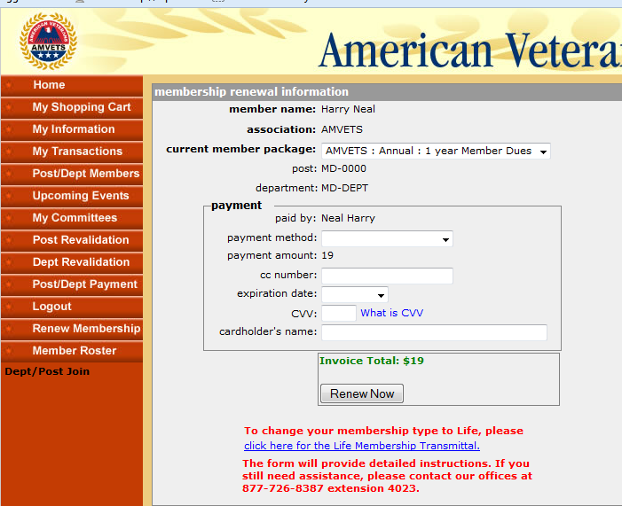
He didn’t put it in yet stupid
Ok, ok put me in as new members only leaders can do that, but were in, let’s do it! Go to Dept/Post Join.

Post/Dept Join(Adding New Members)Step 1
Are you sure we should put you in as a new member. Are we breaking public law 216 ?
Well I was as assigned to the Afghanistan National Navy when I was with the NRO right. And they are allies in time of war right! Click it, click it!

Name Address Phone E-mail
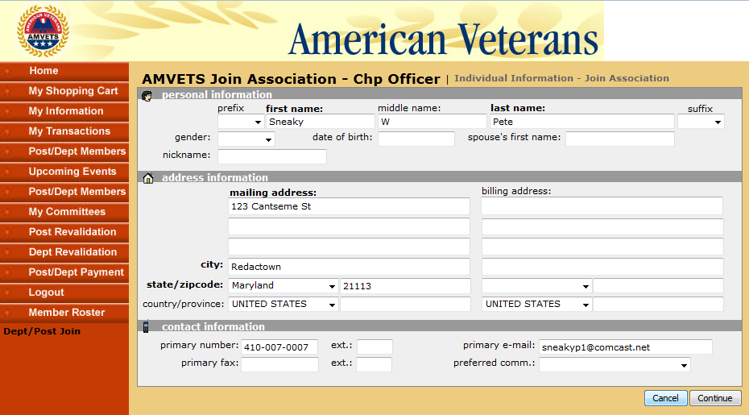
Service Dates
You were in the Afghanistan Navy sounds like KaBULL to me

Member Package

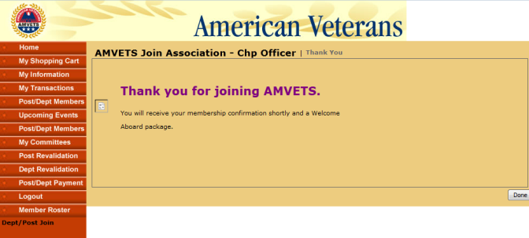

Step one is adding name contact information, service dates amd selecting the membership package. Another form, Post Dept Payment, is where you will find the invoice. Notice there is a membership number assigned with the invoice.

Post/Dept Payment Step 2

- You post will appear, do not enter any information in the white boxes, select Retrieve Open Invoices for All Members and wait. All post members who owe money will appear.
- Put a check in the box select recalculate totals
Put in your credit card information. Select apply payments and you are done.

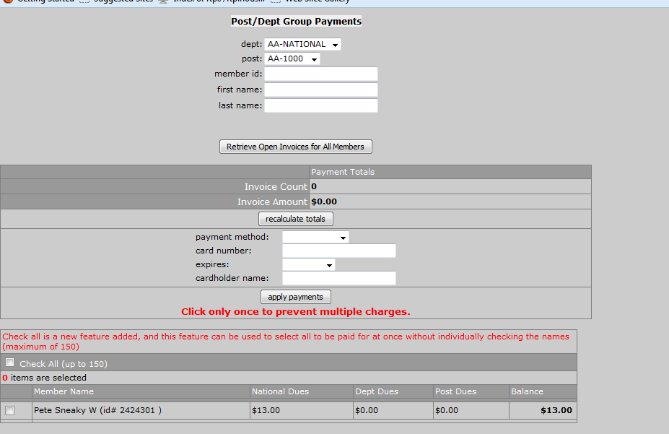
Put in the credit card info hit apply payments and the money is sent an email goes to the confirmation contact

We didn’t blow anything up yet. It’s Easy
Notice the Post Dues amount is blank on the invoice form. You deposited the entire check in your Posts account and captured your dues. The invoice only takes National and Dept dues out of your account. Once a month National HQ sends a refund check to the Departments. We encourage members to login and renew their membership online. When a member renews online we include a refund for the Post dues in the check we send to the Department each month. There are 2 ways for you to know if a post member renews online. One is your e-roster. If the expiration date is current send him his card. A member renewing online also shows on the monthly refund report. The refund report is emailed to the Post Commander and the 1st vice. It also goes to the Dept. Commander and ED.
Member Roster
A member roster is a list of all your members and all the information we have on them. It is presented as an excel spreadsheet. It is pulled from the database. Once it is downloaded it is separate from the database. If you add emails to this roster they won’t appear in the database. If you add members to this roster it doesn’t put the new people in the database. It’s a tool, a picture in time. It can help you manage information.
- Count how many members you have in your post or department
- See how many emails and service dates you have
- Get a list of emails to use
- See who needs to renew
- Get phone numbers of members
- See how many annuals you have and how many life members you have.

Login your level of access is determined by your position

Post Leaders with Access Department Leader with Access
Post Commanders Department Commander
Post 1st Vice Department 1st Vice
Post Adjutant Department Adjutant
Post Renewal Contact Department Renewal Contact
Post Finance Officer Department Executive Director

Department Leaders see all the posts, Post leaders only see the Post roster
The last revalidation date appears next to the Post number.

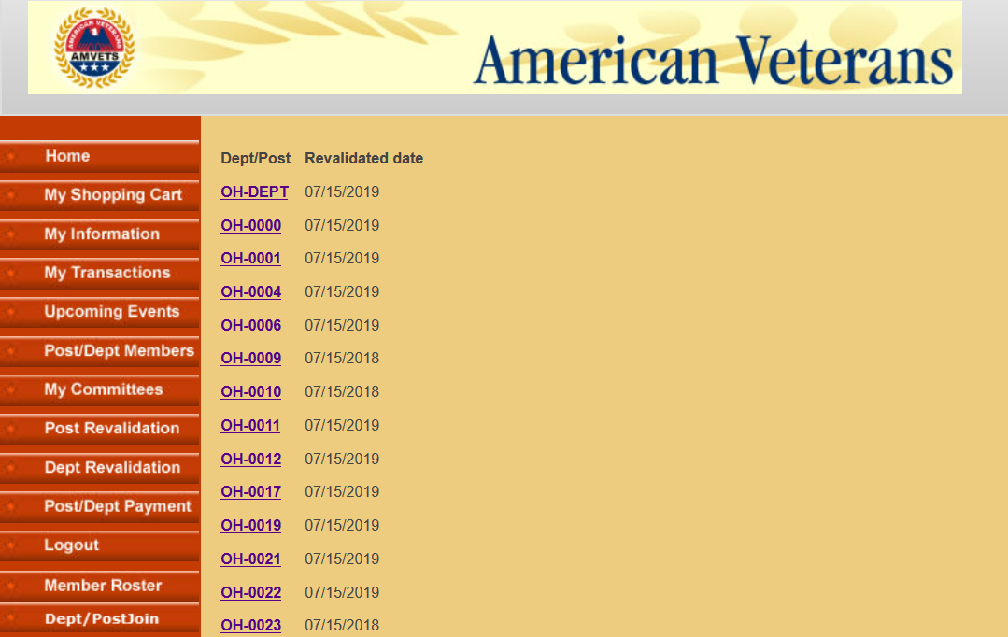
Dept leaders can see the Roster of all the members in the state. It shows all the posts and all the members. They can also look at each Post separately. When letters are blue and underlined it is a link, you can click on it.
After you click on a post the computer asks if you would like it opened or saved. Click OK and you will see the spreadsheet
Post E-Roster
This is what a roster looks like. Columns are reduced so we don’t see any personal data but you can still see the headings. This is a downloaded excel spreadsheet. It is a picture of the database but it is not connected to the database. Additions and deletions to this sheet do not enter the database. This is a tool for leaders to manage their posts. If you print it and keep it in your pocket it becomes out of date quick. Develop the habit of pulling it when you have a question. You can pull it for meetings and have a fresh one each night for the bartender to look at. It is a learned habit to use it fresh online. It is always available to you from any computer. You can also pull it up on your cell phone.
Member Roster Sort
As you can see this excel spreadsheet is always delivered from our database to your desktop sorted alphabetically by last name. When you see hash marks instead of information pull the column wider by clicking the right column line and dragging it with the mouse.
Sorted by last name

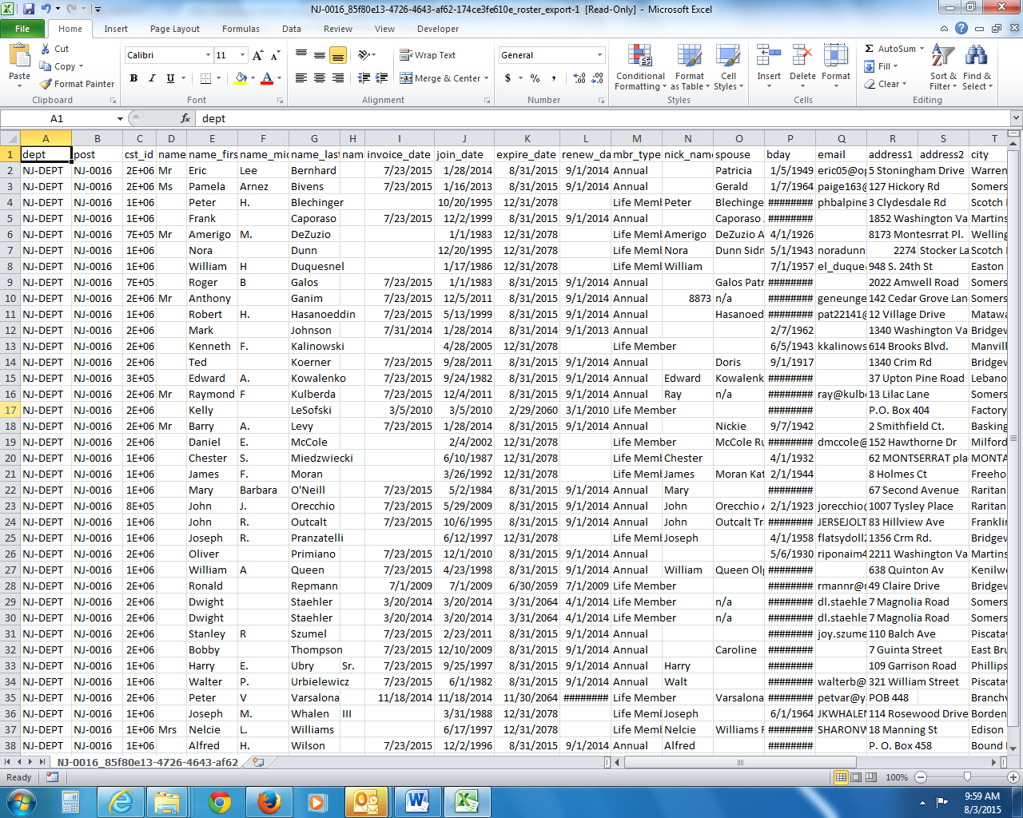

Sorting the K Column (Sample uses the 2014-2015 member year)
As a leader you want to track who is current and who is expired. The K Column has expiration dates.
To sort, click on Data tab>sort box> sort by expire date oldest to newest.
To sort the K column from lowest to highest use the data tab and sort

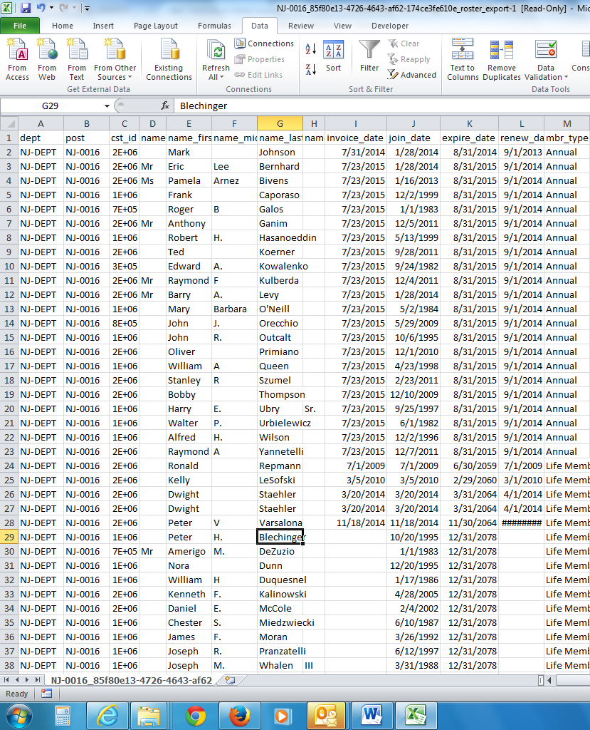
Life members
2014 member not renewed
Current members

K Column management and emails

The K column of expiration dates is one of the most important columns for a manager. When you sort from the least to greatest, A to Z , the members that haven’t renewed for 2 years will be on top followed by the members that are just expired. Next you will see the current members followed by the life members. Notice you have emails and phone numbers to contact these members. Use the buddy system. Pair a current member with an expired member and have them talk. Member engagement is important and all members should be involved. The last columns (not shown above) have the member’s branch of service followed by dates of service. The dates of service are important because it shows AMVETS member composition. Get 100% service dates!
You can email the expired members from this table. Copy and paste the emails into the to: of your emails. Send one reminder to 100 people in one click. (Email etiquette would be to put the emails in BCC so they are not visible to all recipients.)

Filter Annuals
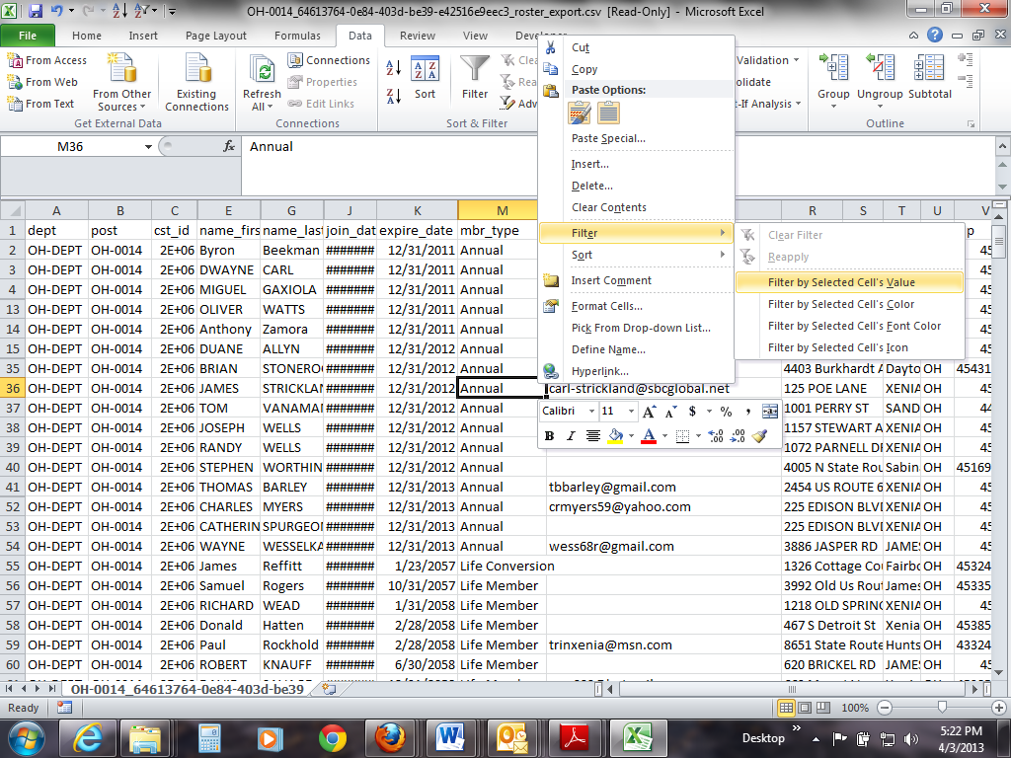
Filter for annual members
The left click puts the box around the cell then the right click opens the filter by selected cells value.
Now the table only shows the annual members. The box in the lower left counts 53 annuals of 296 records

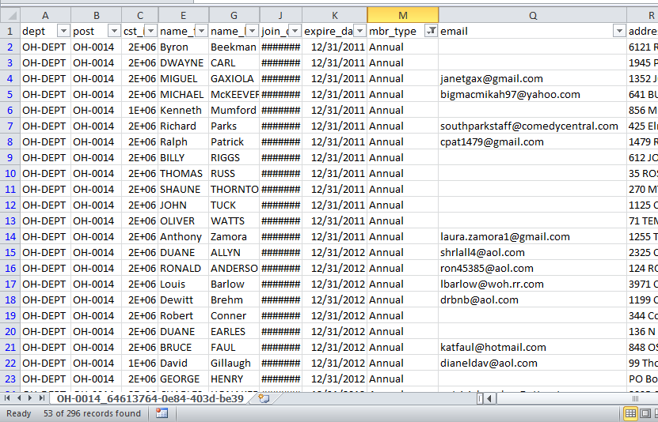
The box in the lower left counts 53 annuals of 296 records

Q column and emails
Q column and emails
Next the Q column was sorted which put all the emails on top. There are 31 emails out of the 53 records. Not bad, you can email around half of the people you need to renew.

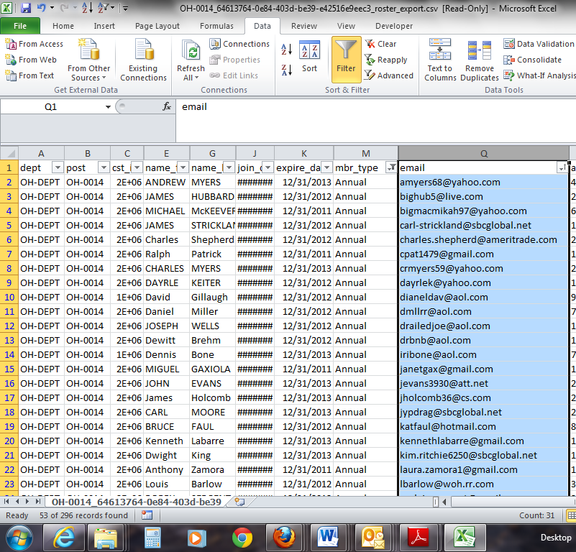
You also have phone numbers for the ones without emails in the X column.
The roster is a post and department manager’s best tool. It is current, pulled right from the database. Get used to pulling it when you need it. See where you are in the renewal process. The sort and filter tools make it easy to see who is current.

Recap and Test: Draw a line to the button.
- All members can edit their personal information.
- All annual members can renew membership online.
- Leaders can add new members to the database
- Leaders can pay for new and renewals online
- Leaders can pull rosters and use them as tools.

Revalidation
revelations and transitions
Consider this timeline, Post Elections according to our CBL should begin May 1-June 30, and assume office no later than July 15. Officers may do a second term
The online revalidation is easy, no paper involved. You can see all the information we have on your post like insurance dates, ein number and leaders. You can change your 3 addresses; mailing, meeting and renewal. You can add or delete Sons Aux and Riders. You can change officers using their member numbers. When you do the last page, revalidation, an email is sent to National and the Dept ED and the database is updated. Now we need to work on flying cars.

Post Revalidation Can be done here if you have access. Revalidate here, save a tree.

Replacing Lost Cards Printing a free paper card and Purchasing Life Gold Cards.
Once a member logs in go to my shopping cart and print a card for free, take a cellphone picture, order a replacement plastic card or a Gold Life Card. Gold cards are guaranteed for Life.
Members checkout with their credit card.

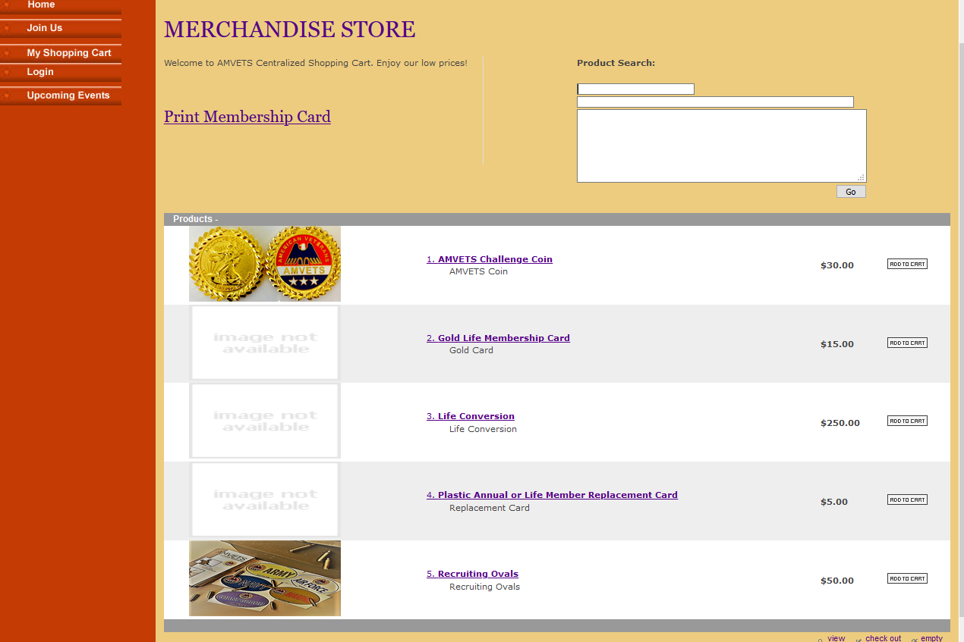

Transferring Membership
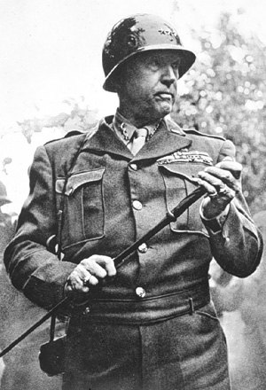
Command Transfers:
Transfers can be accomplished through an email from the accepting posts leadership to membersupport@amvets.org Always cc your Dept. You must be in good standing (current in your dues) to transfer.

- Member requests a transfer.
- New Post accepts member.
- New Post notifies losing post.

Sample email: NY-22 accepts Jim Strand (623551) as a member.
AZ- 55’s 1st Vice, Smith, was notified by phone and does not object.
Commander Cody NY-22 (or post 1st vice or Adjutant)
Sample email: Bill Smith (712551) has no outstanding Debts to NY-22 and can be transferred to Member at Large.
Commander Cody NY-22 (or 1st vice or Adjutant)
If you prefer, the paper transfer form available on our website under membership. It requires the same information in written form. The paper form takes as 7-30 days to get all the signatures in the mail. This transfer can be accomplished with a phone call and email.
Note; CC your Dept, ask your Dept for the Member at Large list and recruit!

Recruiting Kits
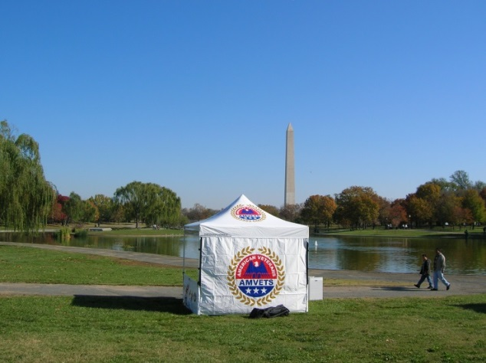
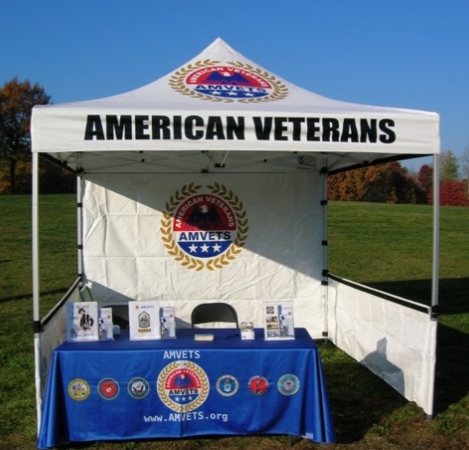
Department Leaders Consider supporting your Post recruiting efforts with an AMVETS professional presentation. We designed and sourced these tablecovers. They are $165 from Tray printing call Bill at 410-440-4928

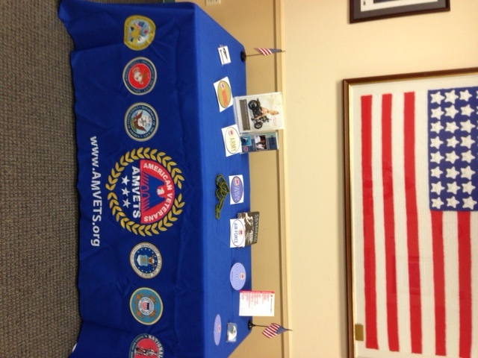

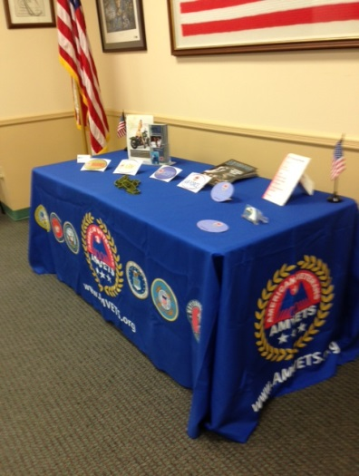

Departments are encouraged to develop recruiting kits to help their posts grow. This tablecloth is from Tray Printing Call Bill Ames at 410-440-4928. The tent is available from Promotional Design Group in California; ask for George: 626-579-4454. Plastic cards and brochure holders are available at office stores like Staples and Office Depot. HQ will provide national brochures. email: membersupport@amvets.org with date of your event.

Commemorative Partner http://www.vietnamwar50th.com/

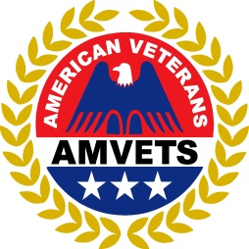

Our active membership is the Vietnam ERA Veteran. Sataistics show there 700,000 to 800,000 Vietnam ERA Veterans alive today. Make an effort to recruit these Veterans. They are the largest group of veterans in America. An excellent way to get involved is to become a Commemorative Partner with the DOD initiative. Every Post Commander, State ED and Commander should insure they are part of this program. Once your Department has signed on get your posts to sign on. HQ worked with DOD early in the program helping to develop the commemorative flag. Gen Kicklighter and his staff have stopped by for briefings. We are extremely impressed with DODs efforts to show respect to the Vietnam ERA Veteran. They are also in the age demographic to give back. Look around, AMVETS leadership is the Vietnam ERA Veteran. Let the 800,000 Vietnam ERA Veterans know AMVETS was there and invite them to join!
"Of the 2,709,918 Americans who served in Vietnam, Less than 850,000 are estimated to be alive today, with the youngest American Vietnam veteran's age approximated to be 54 years old."
All Departments and Posts should be Commemorative Partners.
When you join your Post gets a flag and a letter signed by the Secretary of Defense
http://www.vietnamwar50th.com/

Member edit, new card and renew online
This link will get you to our web page but first scroll down to review the process.
www.AMVETS.org
Select Member ship login

All Members can Login

Your login name is your email your password is your membership number.

Member Edit and Renew online
Update your address, phone, email and service dates!
Get a new card in My Shopping Cart.

Select Edit

Service dates and Emails
Member Renew Membership
You saved me.

Leader Access
Post and Dept Leaders can add emails, service dates and change addresses for their members using the Post/Dept Members Form.

This link will get you to our web page but first scroll down to review the process.
Select Member ship login
www.AMVETS.org

All Members Can Login and update their records.
Only Leaders can make changes to other records. When you use forms, you are updating the database.
Changes you make appear immediately in the database. Your member roster (excel spreadsheet) updates at midnight. Changes made today will appear on your member roster tomorrow.

Your email is your login name your membership number is your password. If it doesn’t work call us to reset it. 800-726-8387

and password.

Leader Access
To update your posts roster select Post/Dept Members
The next screen will give you a blue link for you post. Click it and you can search the roster,

The next screen is your search screen. If you are looking for smith, type smi in the last name block. You will get all members with smi in the last name. Less search criteria is better. If you put all the information in the search boxes and there is a spelling difference you won’t get a hit

Now you can click on the name of the member and update information. Add emails and service dates. When your post has 100% emails and service dates call me for a reward! 301-683-4020.
You can also indicate a member is deceased by checking the box.

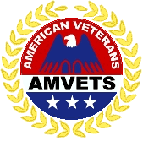
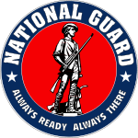
America’s National Guard
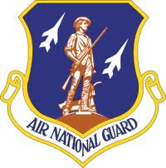
AMVETS Appreciates your Service to America. We are chartered by Congress to help Veterans! We have helped veterans for 60 years. The GI Bill and the VA home loans you earned were fought for and protected by AMVETS members. We also have service officers to work your injury and disability claims through the VA. Congress only allows actively serving Military, National Guard, Reserves, Coast Guard and honorably discharged Veterans to join AMVETS. This elite group of Americans is you. You are the 1 in 10 eligible for membership in AMVETS. The other 9 did not sign on the dotted line to put their lives at risk for their country.
AMVETS works for you every day! Join our team. We appreciate your service and will keep your sacrifices on the forefront of America’s thoughts. We will make sure our Government Honors its commitment to Veterans and keeps it promise to take care of veterans and their families. We see the evolving military and the increased demands placed on the men and women in the National Guard. We will insure there is a place at the table when you return. There is now a place for the National Guard at the Joint Chiefs table.
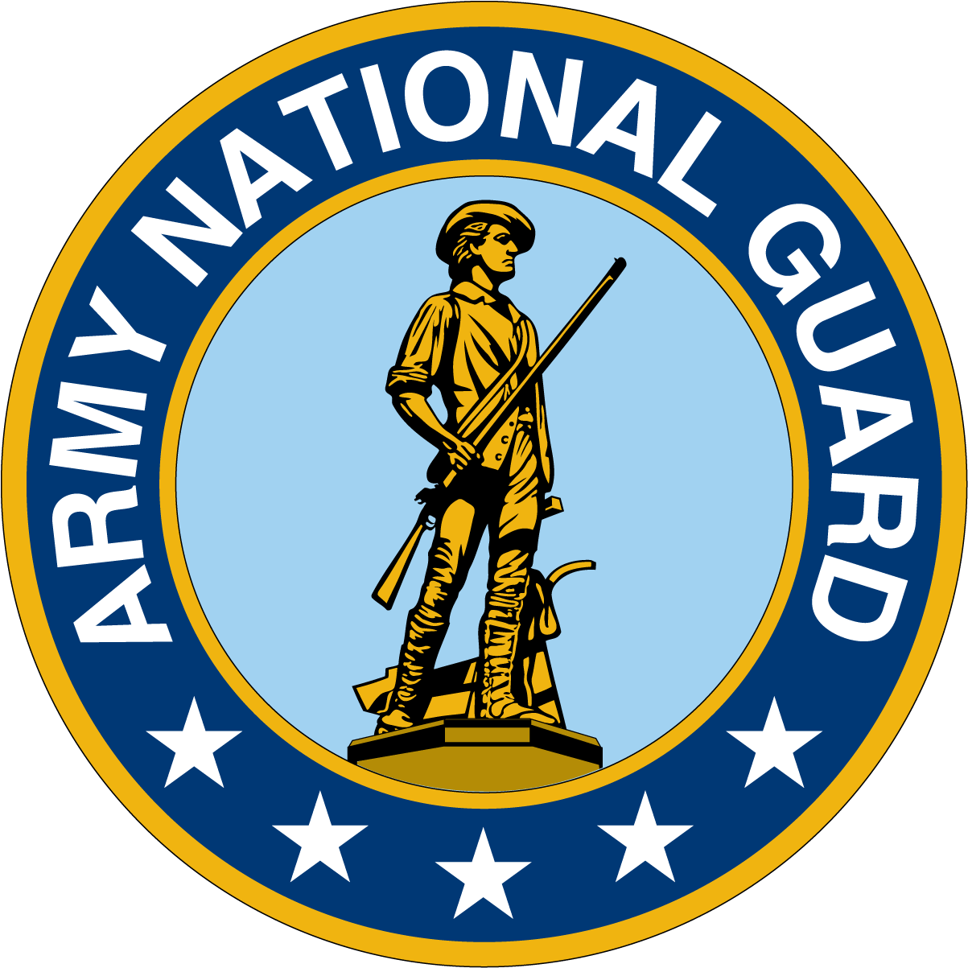
The National Guard continues to demonstrate its war fighting ability. In Iraq and Afghanistan, the National Guard has augmented the active military to the point the guard is indistinguishable from the active military. We will continue to fight for equal promotion and retirement packages for the National Guard.

I WANT YOU
For AMVETS POST 1776
Call membership for a copy of this in word so you can add your post information

AMVETS (American Veterans) FAQs

What is AMVETS? AMVETS is an abbreviation for American Veterans. AMVETS members are active duty and honorably discharged veterans from all branches of service. We are chartered by Congress to assist veterans in all aspects of their lives, from fighting for full benefits to finding decent jobs.

Do you have to serve in combat to become an AMVETS member? Combat service is not a requirement. All active duty and honorably discharged military personnel, National Guard and Army Reserves are eligible to become AMVETS members, making AMVETS the most inclusive veteran service organization in the country.

What is the cost? Annual dues are $30 a year when you join online as a member-at-large. Life membership is $250.

What is a Member-at-Large (MAL)? When you join online through the AMVETS.org website, you select the state of your choice. You can become a MAL in your home state or the state in which you are stationed. MALs have access to all AMVETS canteens and restaurants as well as member discounts. Members-at-large do not have a vote in AMVETS elections. To be a voting member of AMVETS, you must join a Post.

How do I join an AMVETS Post? You can request a transfer from MAL status to a Post. By joining a Post, you actively help veterans through local AMVETS programs. You can do a zip code search at AMVETS Nationwide followed by an email or call the Post point of contact. Let the point of contact know you are interested in joining the Post. The Post will take care of the transfer.

How was AMVETS started? When troops returned to America at the end of WWII, many used their newly earned GI bill benefit to complete a degree, a goal usually reserved for the wealthy. Veterans found they were comfortable with other veterans on campus, and they formed veteran’s clubs. These clubs became active in shaping American policy, and on July 23, 1947, President Harry Truman signed public law 216, which granted a Congressional Charter to AMVETS (American Veteran).

My husband is in the military. Can I also join AMVETS? Yes. You can join the AMVETS Ladies Auxiliary. The Ladies Auxiliary works closely with AMVETS posts on programs to help veterans. Other programs include Junior AMVETS, they organize youth programs, promote the Americanism Program, build Drill Teams and create Service Programs. Junior members are ages 5-17. http://www.amvetsaux.org/

My Dad is a veteran. Can I join? Yes. You can join the Sons of AMVETS. Many posts have a Sons of AMVETS program working closely with AMVETS members to support returning veterans. http://www.sonsofamvets.org/

How can I join the AMVETS Riders? AMVETS Riders are a dedicated, patriotic group of veteran motorcycle riders who hold true to an unwavering respect for our Nation, our Flag, and our Military. First join AMVETS then contact the riders https://www.amvetsridersnational.org/

I don’t have any military members in my family. How can I support the AMVETS mission? You can donate directly to AMVETS through this Donate Now link. You can also donate your used vehicle (car, truck, motorcycle, RV, sail or motorboat, even aircraft) to AMVETS by calling 1-877-999-8322. Out thrift stores support our free VA claims work.

What is AMVETS doing to help veterans? Our National Service Officers’ file claims for all veterans, free. Our Career Center will place 500 veterans in jobs this year. We offer free Warrior Transition workshops to help veterans cope with the stresses of service. We fly family members to the bedside of injured veterans. We monitor and champion Legislation supporting veterans. The AMVETS HEAL Team ensures veterans with medical needs have access the best quality mental health and specialized services (traumatic brain injury, polytrauma, post-traumatic stress) and live longer, healthier lives. Posts throughout the country find and furnish housing for homeless vets. We feed and clothe veterans in need. We provide honor guards at military funerals for veterans. AMVETS is hosting the largest veteran’s demonstration in America, join us and the AMVETS Riders for the Memorial Day Rolling to Remember ride. POWs MIA’s and the 20 veteran suicides today.
What is my next step? Join us at www.amvets.org and make a difference in the lives of our Nations veterans! Call AMVETS National Headquarters at 877-726-8387 for assistance.

Build a Post in 4 easy steps.
New AMVETS Post
AMVETS has an honorable history helping veterans in communities throughout America. Building an AMVETS Post allows your members to shape your outreach. It is 4 easy steps Contact your state AMVETS Department to help you. Call us with question at 877-726-8387. Go to www.amvets.org for information and resources.
1. A post requires 10 Members.
Put new members number on your charter form and we will transfer current members to your new post. The post charter form is below.
-------------------------------------------------------------------------------------------------------------------------------
2. This is the link for the post Officer -Revalidation form on our website. It is under the resources link on www.amvets.org Once Charter Members (at least 10 are established they vote on the Post Officers. The Post Officers are listed on page 2 of the form. The front page has a space for the Official Contact and the Renewal Contact. Emails are essential!
http://amvets.org/wp-content/themes/amvetshq/docs/membership-form-02.pdf
-------------------------------------------------------------------------------------------------------------------------------3. This is the link for the sample Constitution and Bylaws. CBL’s must be established and agreed upon by the post membership.
http://amvets.org/wp-content/themes/amvetshq/docs/membership-form-25.pdf

-------------------------------------------------------------------------------------------------------------------------------
- EIN Number: It takes about 10 minutes to apply online. AMVETS Group exemption number is GEN 0838. These Tips will help

http://www.irs.gov/businesses/small/article/0,,id=102767,00.html

AMVETS
Post Charter Application
We the undersigned, who are currently serving or previously served honorably in an Active, Reserve or National Guard component of the Armed Forces of the United States of America, collectively request the issuance of an AMVETS Charter for a new Post to be located at _________________________________________
In the city of____________, in the state of_______, in the county of___________,
hereafter to be known as AMVETS Post#___________.
We seek this charter by virtue of our sincere belief the formation of an AMVETS post offers an excellent opportunity to continue serving our nation so we may help preserve our cherished American principles; so we may organize to help veterans and others who are less fortunate than ourselves; and so we may promote a positive image in our lives, our community, our state, and our nation. We certify that we have served, or are still serving honorably, and we solemnly swear to uphold the Constitution of the United States of America against all enemies foreign and domestic. We willingly accept the principles of AMVETS and agree to abide by the provisions of our Post, State, and National Constitution and Bylaws.
Charter Members
Name Signature New or transfer
1______________ ________________ _________
2______________ ________________ _________
3______________ ________________ _________
4______________ ________________ _________
5______________ ________________ _________
6______________ ________________ _________
7_______________________________ _________
8______________ ________________ _________
9______________ ________________ _________
10_____________ ________________ _________

AMVETS
Post Charter Checklist

The Charter Application for Post____________________ has been fully executed and properly certified by appropriate Post and Department Officials. The package includes:
________1.Charter Application (10 founding members of the post add checks and transfer papers))
________2.Revalidation & Officers Form (voted by members and certified by post official)
________3. Constitution and By Laws (CBL) adopted by members and approved by the Dept. JA
_______ 4. EIN obtained under AMVETS Group Exemption Code (or proof of application)

The following is needed if a post is located in a leased or owned facility
_______ _____ Liability Insurance for facility leased or owned
______ ______ Articles of Incorporation for a facility with Clubroom
I certify that this new post has complied with all requirements to receive an AMVETS Charter.
_______________________________ __________________
Post Commander Date
________________________________ __________________
Post Executive Director Date

AMVETS Flag Day June 14
Everyone Loves a Parade. Honor our U.S. Flag!

When is Flag Day and what is Flag Day? FLAG DAY is celebrated every year on June 14. It commemorates the adoption of the flag of the United States of America on June 14, 1777 by resolution of the Second Continental Congress. In 1916, President Woodrow Wilson issued a proclamation that officially established June 14 as Flag Day. In August 1946, National Flag Day was established by an Act of Congress. In July 1947 Congress Chartered AMVETS. Flag Day is not an official Federal holiday. It is at the President's discretion to officially proclaim the observance.
On June 14, 1937, Pennsylvania became the first state to celebrate Flag Day as a state holiday. New York statutes designate the second Sunday in June as Flag Day, a state holiday. Fairfield, Washington has held a Flag Day parade since 1910. Appleton, Wisconsin has held National Flag Day parade since 1950. Quincy, Massachusetts started its annual Flag Day parade in 1952. The largest Flag Day parade is held annually in Troy, New York, and typically draws about 50,000 spectators. The Three Oaks, Michigan Flag Day Parade is held annually on the weekend of Flag Day and is a three-day event. In Washington, D.C. Flag Day is celebrated heavily through the 7th and 8th Wards in D.C., it is tradition in these wards to slow smoke various meats and vegetables.
If there isn’t a Flag Day parade in your town, take the initiative, work with your local city and do a parade. AMVETS National urges you to make every AMVETS Post become the leaders in remembering and commemorating FLAG DAY in your community and all over the U.S.A. every year.
What should we do for Flag Day June 14th?
- Department Leaders find out where your state or local Flag Day parade is and join the parade, if none scheduled, start a parade.
- Post leaders call your local town council and ask what they do for Flag Day. If nothing, suggest an AMVETS parade and event.
- Set up flag retirement collection boxes for worn flags in your town. Inform the media, local government and the community of your retirement flag collection boxes, and why it is important to properly retire your worn U.S. Flag. Setup with local Boy Scouts to properly retire the flags..
- Give a framed AMVETS Flag Award certificate to a business, individual, or government entity correctly flying a U.S. Flag.
See AMVETS National program #18.
- Leave an AMVETS Flag appreciation letter at the house of an individual flying a flag at their home, also leave a membership brochure.
- Contact local schools and volunteer to have Post members give a free school assembly with the students to teach them correct Flag etiquette, rules, laws and history of our U.S. Flag.
Building and installing U.S. Flag retirement boxes and learning about AMVETS and U.S. Flag etiquette is a great Eagle Scout Project.

