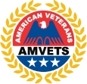
In Memoriam
AMVETS
American Veterans

HONORS THE MEMORY OF

is certificate is awarded by a grateful organization in recognition of devoted selfless dedication to the service of AMVETS our Country, State and Community.

Faithfully did they answer their Country’s call and nobly did they serve. ough for them the bugle ’s clarion can be stilled and the battle ags unfurled, yet will we who served with them forever remember their devotion to the ideals of America, their dedication to the cause of liberty and their love for God and Country.

AMVETS PERPETUATES THE MEMORY OF ALL VETERANS WHO MAKE THE SUPREME SACRIFICE

G iven in the City of Lanham, M aryland this day of,
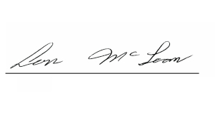
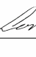
Post Commander National Commander

